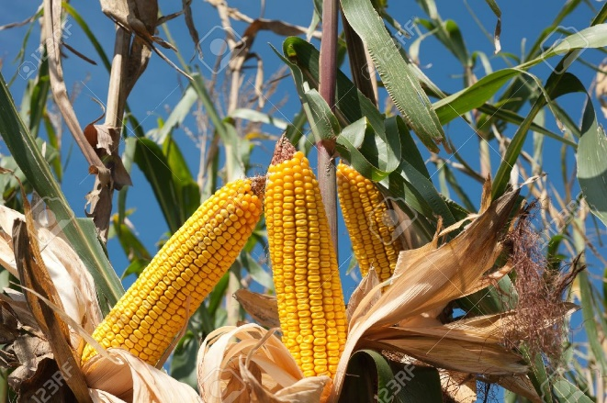
CHARITABLE GIFTS
OF GRAIN
GROW WITH US
SUPPORT
UNITED WE BUILD
Through commodity donation.

ADVANTAGES OF DONATING GRAIN
- Donating grain is not recorded as income; so you may save on some taxes:
  - Self –employment tax
  - State & county taxes
  - Federal income taxes
- You may avoid costly tax deduction phase-outs.
- You may pay less income tax on you social security.
- You may receive additional tax benefits.
- The grain you contribute will not count as income in your government payments limitation caps calculation.

TIPS FOR MAKING GIFTS
- Farmers notify the agent of their intent to donate ‘x’ number of bushels of this load to the United We Build.
- Sale of Commodity: United We Build authorizes the sale of the commodity.
- Documentation: Receipt/check issuance showing United We Build as owner of the grain
- Area grain farmers can take advantage of this opportunity with the sale of corn or beans.
- Area livestock farmers can take advantage of this opportunity with sale of cattle of hogs.
- Hay sales also qualify as a commodity gift.

Please contact Jim Klein @ (563) 872-3356 for further information.
Professional Advisor: Farmers should always consult their tax advisor to determine tax ramifications prior to making a gift to a charitable organization. Information in this brochure is for hypothetical purposes and not intended as legal advice.

