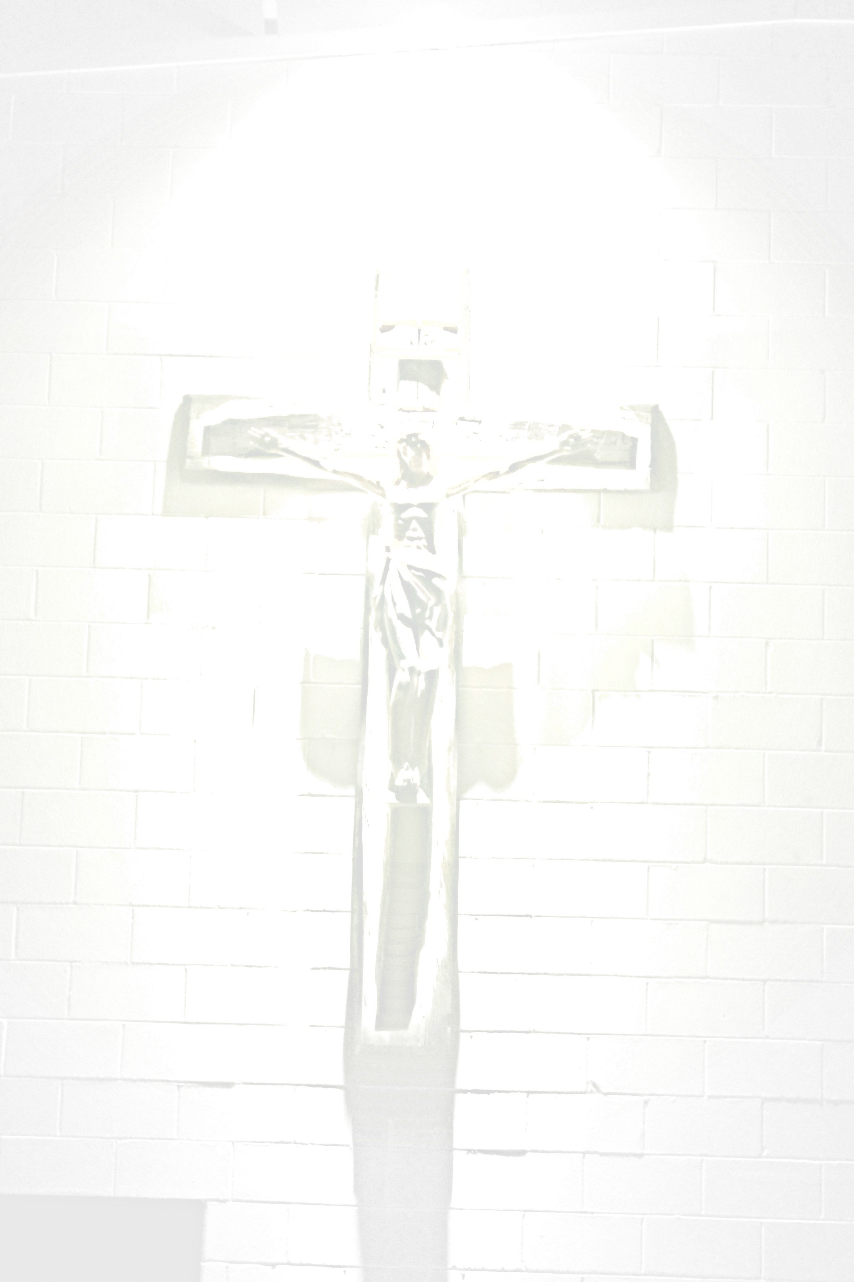
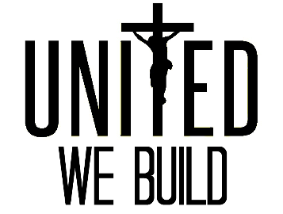

COMMITMENT FORM
Donor: _______________________________________________________________________
Primary Contact: _______________________________________________________________
Street Address: ________________________________________________________________
City, State, Zip Code: ____________________________________________________________
Telephone: __________________________ Email: ____________________________________
In consideration of God’s blessings and the plans and needs of the United We Build capital campaign, I/We hereby pledge a total of $_________________. The following represents my preferred payment terms:
- Lump-Sum – To be paid on or around: _________________________ (month/day/year)

- Installments – Frequency: _______________ (monthly, quarterly, semi-annual, annual)

  - For the duration of: _______________ (please consider 5 year pledges)
  - Beginning: ______________________ (initial installment date)

Signature: _______________________________________________ Date: ________________

I/We would like to be listed in publications and donor board (please select one):

- Anonymous
- With other donors as: _______________________________________________

Do you wish to be contacted regarding information regarding gifts of stock? _____ Yes
Would you be interested in automatic withdrawals to assist with installments? _____ Yes

United We Build c 405 Franklin Street, Bellevue, IA 52031 c 563-872-3234 c DBQ012sec@arch.pvt.k12.ia.us
For Our Records, Person Contacting You Regarding Gift: ___________________________________________________

Gifts to the United We Build Capital Campaign are tax deductible to extent provided by law.
No goods and/or services have been provided to the donor.

Please Make Checks Payable to “United We Build.”

